**Набор развивающих карточек**

**Дидактическая игра «Шифровка»**

**Возраст:** старший дошкольный возраст

**Цель:** развитие концентрации и переключения внимания.

**Задачи:**

- формировать умение **расшифровывать слова,** где буквы кодированы цифрами;

-закреплять умение переключаться с одного объекта на другой;

- закреплять знание букв русского языка;

- закреплять знание цифр (до 20);

-закреплять навык чтения;

-развивать память, внимание, логическое мышление.

**Требуемые для работы знания и умения** **ребенка:**

-умеет переключаться с одного объекта на другой;

-знает цифры;

-знает буквы и может их графически изобразить;

-владеет навыком чтения простых слов.

**Ожидаемые результаты:**

- ребенок может соотнести цифры и назначенные им буквы и прочитать зашифрованные слова.

**Инструкция:**

Комплект карточек «Шифровка» состоит из четырех блоков. Каждому блоку соответствует свой цвет (от тёмно-синего, до светло-голубого).

**Первый блок**: односложные слова из трех букв. Цвет вопроса – **синий**. В комплект входит 16 карточек. На каждой карточке зашифровано слово. *Слова, зашифрованные на карточках*: бак, зуб, кот, нос, сом, бык, йод, маг, суп, пух, дом, кит, мак, , дым, ком, сок.

**Второй блок**: двухсложные слова из четырех букв. Цвет карточек – **красный**. В комплект входит 10 карточек. На каждой карточке зашифровано слово. *Слова, зашифрованные на карточках*: вата, зубы, ноги, губы, коза, ноты, муха, мина, сито, сова.

**Третий блок**: двухсложные слова из пяти букв. Цвет карточек – **зеленый**. В комплект входит 10 карточек. На каждой карточке зашифровано слово. *Слова, зашифрованные на карточках*: батон, кабан, санки, будка, кубок, вагон, миска, тыква, гамак, нитка.

**Четвертый блок**: трёхсложные слова из шести букв. Цвет карточек – **желтый**. В комплект входит 10 карточек. На каждой карточке зашифровано слово. *Слова, зашифрованные на карточках*: бумага, заноза, синица, вагоны, финики, калина, малина, домино, дубина, сапоги.

Каждая карточка состоит из двух листов склеенных вместе и покрытых ламинирующей пленкой. На верхнем листе, в центре карточки, находится поле с зашифрованным словом, а выше расположена таблица с ключом. На нижнем листе изображена отгадка.

Ребенку необходимо расшифровать слово, путем замены цифр на буквы и прочитать его. А проверить себя, ребенок может при помощи светового фонарика.

Для работы с карточками, необходимо подготовить фломастер или маркер, а также влажную салфетку. Для того чтобы посмотреть ответ, необходимо посветить фонариком на пустое поле между знаками вопроса.

В случае неправильного написания буквы, ребенок может её стереть влажной салфеткой и написать заново. Благодаря тому, что карточки покрыты ламинирующей плёнкой, они будут служить долго, и не потеряют привлекательный внешний вид.

Знакомство с игрой и закрепление полученных навыков можно проводить, как с небольшой подгруппой детей, так и индивидуально. В дальнейшем, дети сами могут зашифровывать свои слова и писать друг другу письма, используя данный шифр.

|  |  |  |  |  |  |  |  |  |  |  |  |  |  |  |  |  |  |  |  |
| --- | --- | --- | --- | --- | --- | --- | --- | --- | --- | --- | --- | --- | --- | --- | --- | --- | --- | --- | --- |
| **А** | **О** | **У** | **Е** | **Ы** | **Ч** | **М** | **Н** | **К** | **Г** | **Х** | **И** | **Ф** | **Б** | **П** | **Д** | **Т** | **С** | **З** | **Ц** |
| **1** | **2** | **3** | **4** | **5** | **6** | **7** | **8** | **9** | **10** | **11** | **12** | **13** | **14** | **15** | **16** | **17** | **18** | **19** | **20** |

|  |  |  |
| --- | --- | --- |
| **14** | **1** | **9** |
|  |  |  |

 



|  |  |  |  |  |  |  |  |  |  |  |  |  |  |  |  |  |  |  |  |
| --- | --- | --- | --- | --- | --- | --- | --- | --- | --- | --- | --- | --- | --- | --- | --- | --- | --- | --- | --- |
| **А** | **О** | **У** | **Е** | **Ы** | **Ч** | **М** | **Н** | **К** | **Г** | **Х** | **И** | **Ф** | **Б** | **П** | **Д** | **Т** | **С** | **З** | **Ц** |
| **1** | **2** | **3** | **4** | **5** | **6** | **7** | **8** | **9** | **10** | **11** | **12** | **13** | **14** | **15** | **16** | **17** | **18** | **19** | **20** |

|  |  |  |
| --- | --- | --- |
| **19** | **3** | **14** |
|  |  |  |

 



|  |  |  |  |  |  |  |  |  |  |  |  |  |  |  |  |  |  |  |  |
| --- | --- | --- | --- | --- | --- | --- | --- | --- | --- | --- | --- | --- | --- | --- | --- | --- | --- | --- | --- |
| **А** | **О** | **У** | **Е** | **Ы** | **Ч** | **М** | **Н** | **К** | **Г** | **Х** | **И** | **Ф** | **Б** | **П** | **Д** | **Т** | **С** | **З** | **Ц** |
| **1** | **2** | **3** | **4** | **5** | **6** | **7** | **8** | **9** | **10** | **11** | **12** | **13** | **14** | **15** | **16** | **17** | **18** | **19** | **20** |

|  |  |  |
| --- | --- | --- |
| **9** | **2** | **17** |
|  |  |  |

 

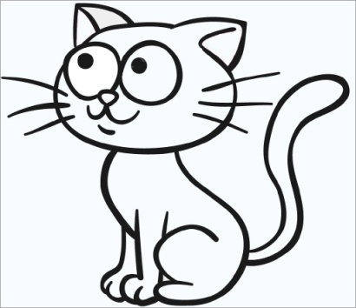

|  |  |  |  |  |  |  |  |  |  |  |  |  |  |  |  |  |  |  |  |
| --- | --- | --- | --- | --- | --- | --- | --- | --- | --- | --- | --- | --- | --- | --- | --- | --- | --- | --- | --- |
| **А** | **О** | **У** | **Е** | **Ы** | **Ч** | **М** | **Н** | **К** | **Г** | **Х** | **И** | **Ф** | **Б** | **П** | **Д** | **Т** | **С** | **З** | **Ц** |
| **1** | **2** | **3** | **4** | **5** | **6** | **7** | **8** | **9** | **10** | **11** | **12** | **13** | **14** | **15** | **16** | **17** | **18** | **19** | **20** |

|  |  |  |
| --- | --- | --- |
| **8** | **2** | **18** |
|  |  |  |

 

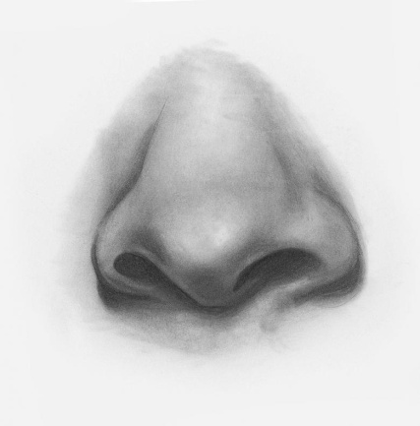

|  |  |  |  |  |  |  |  |  |  |  |  |  |  |  |  |  |  |  |  |
| --- | --- | --- | --- | --- | --- | --- | --- | --- | --- | --- | --- | --- | --- | --- | --- | --- | --- | --- | --- |
| **А** | **О** | **У** | **Е** | **Ы** | **Ч** | **М** | **Н** | **К** | **Г** | **Х** | **И** | **Ф** | **Б** | **П** | **Д** | **Т** | **С** | **З** | **Ц** |
| **1** | **2** | **3** | **4** | **5** | **6** | **7** | **8** | **9** | **10** | **11** | **12** | **13** | **14** | **15** | **16** | **17** | **18** | **19** | **20** |

|  |  |  |
| --- | --- | --- |
| **18** | **2** | **7** |
|  |  |  |

 

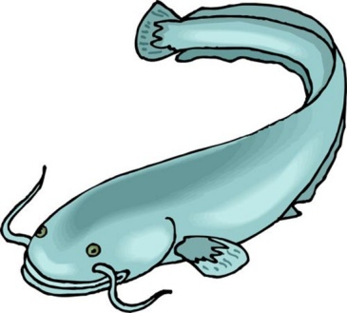

|  |  |  |  |  |  |  |  |  |  |  |  |  |  |  |  |  |  |  |  |
| --- | --- | --- | --- | --- | --- | --- | --- | --- | --- | --- | --- | --- | --- | --- | --- | --- | --- | --- | --- |
| **А** | **О** | **У** | **Е** | **Ы** | **Ч** | **М** | **Н** | **К** | **Г** | **Х** | **И** | **Ф** | **Б** | **П** | **Д** | **Т** | **С** | **З** | **Ц** |
| **1** | **2** | **3** | **4** | **5** | **6** | **7** | **8** | **9** | **10** | **11** | **12** | **13** | **14** | **15** | **16** | **17** | **18** | **19** | **20** |

|  |  |  |
| --- | --- | --- |
| **14** | **5** | **9** |
|  |  |  |

 



|  |  |  |  |  |  |  |  |  |  |  |  |  |  |  |  |  |  |  |  |
| --- | --- | --- | --- | --- | --- | --- | --- | --- | --- | --- | --- | --- | --- | --- | --- | --- | --- | --- | --- |
| **А** | **О** | **У** | **Е** | **Ы** | **Й** | **М** | **Н** | **К** | **Г** | **Х** | **В** | **Ф** | **Б** | **П** | **Д** | **Т** | **С** | **З** | **Ц** |
| **1** | **2** | **3** | **4** | **5** | **6** | **7** | **8** | **9** | **10** | **11** | **12** | **13** | **14** | **15** | **16** | **17** | **18** | **19** | **20** |

|  |  |  |
| --- | --- | --- |
| **6** | **2** | **16** |
|  |  |  |

 

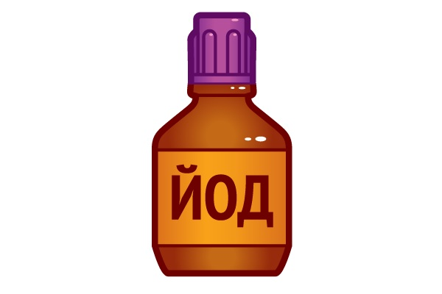

|  |  |  |  |  |  |  |  |  |  |  |  |  |  |  |  |  |  |  |  |
| --- | --- | --- | --- | --- | --- | --- | --- | --- | --- | --- | --- | --- | --- | --- | --- | --- | --- | --- | --- |
| **А** | **О** | **У** | **Е** | **Ы** | **Ч** | **М** | **Н** | **К** | **Г** | **Х** | **И** | **Ф** | **Б** | **П** | **Д** | **Т** | **С** | **З** | **Ц** |
| **1** | **2** | **3** | **4** | **5** | **6** | **7** | **8** | **9** | **10** | **11** | **12** | **13** | **14** | **15** | **16** | **17** | **18** | **19** | **20** |

|  |  |  |
| --- | --- | --- |
| **7** | **1** | **10** |
|  |  |  |

 



|  |  |  |  |  |  |  |  |  |  |  |  |  |  |  |  |  |  |  |  |
| --- | --- | --- | --- | --- | --- | --- | --- | --- | --- | --- | --- | --- | --- | --- | --- | --- | --- | --- | --- |
| **А** | **О** | **У** | **Е** | **Ы** | **Ч** | **М** | **Н** | **К** | **Г** | **Х** | **И** | **Ф** | **Б** | **П** | **Д** | **Т** | **С** | **З** | **Ц** |
| **1** | **2** | **3** | **4** | **5** | **6** | **7** | **8** | **9** | **10** | **11** | **12** | **13** | **14** | **15** | **16** | **17** | **18** | **19** | **20** |

|  |  |  |
| --- | --- | --- |
| **18** | **3** | **15** |
|  |  |  |

 



|  |  |  |  |  |  |  |  |  |  |  |  |  |  |  |  |  |  |  |  |
| --- | --- | --- | --- | --- | --- | --- | --- | --- | --- | --- | --- | --- | --- | --- | --- | --- | --- | --- | --- |
| **А** | **О** | **У** | **Е** | **Ы** | **Ч** | **М** | **Н** | **К** | **Г** | **Х** | **И** | **Ф** | **Б** | **П** | **Д** | **Т** | **С** | **З** | **Ц** |
| **1** | **2** | **3** | **4** | **5** | **6** | **7** | **8** | **9** | **10** | **11** | **12** | **13** | **14** | **15** | **16** | **17** | **18** | **19** | **20** |

|  |  |  |
| --- | --- | --- |
| **15** | **3** | **11** |
|  |  |  |

 



|  |  |  |  |  |  |  |  |  |  |  |  |  |  |  |  |  |  |  |  |
| --- | --- | --- | --- | --- | --- | --- | --- | --- | --- | --- | --- | --- | --- | --- | --- | --- | --- | --- | --- |
| **А** | **О** | **У** | **Е** | **Ы** | **Ч** | **М** | **Н** | **К** | **Г** | **Х** | **И** | **Ф** | **Б** | **П** | **Д** | **Т** | **С** | **З** | **Ц** |
| **1** | **2** | **3** | **4** | **5** | **6** | **7** | **8** | **9** | **10** | **11** | **12** | **13** | **14** | **15** | **16** | **17** | **18** | **19** | **20** |

|  |  |  |
| --- | --- | --- |
| **16** | **2** | **7** |
|  |  |  |

 

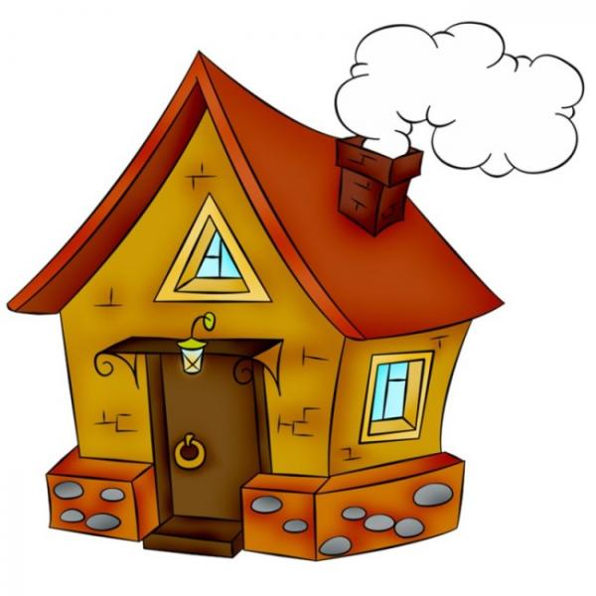

|  |  |  |  |  |  |  |  |  |  |  |  |  |  |  |  |  |  |  |  |
| --- | --- | --- | --- | --- | --- | --- | --- | --- | --- | --- | --- | --- | --- | --- | --- | --- | --- | --- | --- |
| **А** | **О** | **У** | **Е** | **Ы** | **Ч** | **М** | **Н** | **К** | **Г** | **Х** | **И** | **Ф** | **Б** | **П** | **Д** | **Т** | **С** | **З** | **Ц** |
| **1** | **2** | **3** | **4** | **5** | **6** | **7** | **8** | **9** | **10** | **11** | **12** | **13** | **14** | **15** | **16** | **17** | **18** | **19** | **20** |

|  |  |  |
| --- | --- | --- |
| **9** | **4** | **17** |
|  |  |  |

 



|  |  |  |  |  |  |  |  |  |  |  |  |  |  |  |  |  |  |  |  |
| --- | --- | --- | --- | --- | --- | --- | --- | --- | --- | --- | --- | --- | --- | --- | --- | --- | --- | --- | --- |
| **А** | **О** | **У** | **Е** | **Ы** | **Ч** | **М** | **Н** | **К** | **Г** | **Х** | **И** | **Ф** | **Б** | **П** | **Д** | **Т** | **С** | **З** | **Ц** |
| **1** | **2** | **3** | **4** | **5** | **6** | **7** | **8** | **9** | **10** | **11** | **12** | **13** | **14** | **15** | **16** | **17** | **18** | **19** | **20** |

|  |  |  |
| --- | --- | --- |
| **7** | **1** | **9** |
|  |  |  |

 



|  |  |  |  |  |  |  |  |  |  |  |  |  |  |  |  |  |  |  |  |
| --- | --- | --- | --- | --- | --- | --- | --- | --- | --- | --- | --- | --- | --- | --- | --- | --- | --- | --- | --- |
| **А** | **О** | **У** | **Е** | **Ы** | **Ч** | **М** | **Н** | **К** | **Г** | **Х** | **И** | **Ф** | **Б** | **П** | **Д** | **Т** | **С** | **З** | **Ц** |
| **1** | **2** | **3** | **4** | **5** | **6** | **7** | **8** | **9** | **10** | **11** | **12** | **13** | **14** | **15** | **16** | **17** | **18** | **19** | **20** |

|  |  |  |
| --- | --- | --- |
| **16** | **5** | **7** |
|  |  |  |

 

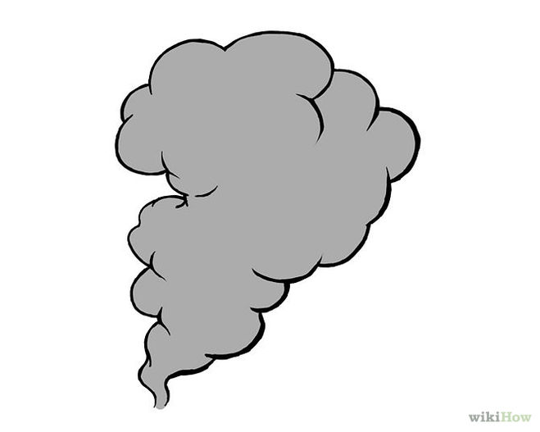

|  |  |  |  |  |  |  |  |  |  |  |  |  |  |  |  |  |  |  |  |
| --- | --- | --- | --- | --- | --- | --- | --- | --- | --- | --- | --- | --- | --- | --- | --- | --- | --- | --- | --- |
| **А** | **О** | **У** | **Е** | **Ы** | **Ч** | **М** | **Н** | **К** | **Г** | **Х** | **И** | **Ф** | **Б** | **П** | **Д** | **Т** | **С** | **З** | **Ц** |
| **1** | **2** | **3** | **4** | **5** | **6** | **7** | **8** | **9** | **10** | **11** | **12** | **13** | **14** | **15** | **16** | **17** | **18** | **19** | **20** |

|  |  |  |
| --- | --- | --- |
| **9** | **2** | **7** |
|  |  |  |

 



|  |  |  |  |  |  |  |  |  |  |  |  |  |  |  |  |  |  |  |  |
| --- | --- | --- | --- | --- | --- | --- | --- | --- | --- | --- | --- | --- | --- | --- | --- | --- | --- | --- | --- |
| **А** | **О** | **У** | **Е** | **Ы** | **Ч** | **М** | **Н** | **К** | **Г** | **Х** | **И** | **Ф** | **Б** | **П** | **Д** | **Т** | **С** | **З** | **Ц** |
| **1** | **2** | **3** | **4** | **5** | **6** | **7** | **8** | **9** | **10** | **11** | **12** | **13** | **14** | **15** | **16** | **17** | **18** | **19** | **20** |

|  |  |  |
| --- | --- | --- |
| **18** | **2** | **9** |
|  |  |  |

 



|  |  |  |  |  |  |  |  |  |  |  |  |  |  |  |  |  |  |  |  |
| --- | --- | --- | --- | --- | --- | --- | --- | --- | --- | --- | --- | --- | --- | --- | --- | --- | --- | --- | --- |
| **А** | **О** | **У** | **Е** | **Ы** | **Ч** | **М** | **Н** | **К** | **Г** | **Х** | **И** | **Ф** | **Б** | **П** | **Д** | **Т** | **С** | **З** | **Ц** |
| **1** | **2** | **3** | **4** | **5** | **6** | **7** | **8** | **9** | **10** | **11** | **12** | **13** | **14** | **15** | **16** | **17** | **18** | **19** | **20** |

|  |  |  |  |
| --- | --- | --- | --- |
| **12** | **1** | **17** | **1** |
|  |  |  |  |

 

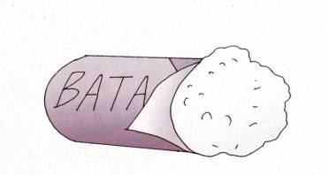

|  |  |  |  |  |  |  |  |  |  |  |  |  |  |  |  |  |  |  |  |
| --- | --- | --- | --- | --- | --- | --- | --- | --- | --- | --- | --- | --- | --- | --- | --- | --- | --- | --- | --- |
| **А** | **О** | **У** | **Е** | **Ы** | **Ч** | **М** | **Н** | **К** | **Г** | **Х** | **И** | **Ф** | **Б** | **П** | **Д** | **Т** | **С** | **З** | **Ц** |
| **1** | **2** | **3** | **4** | **5** | **6** | **7** | **8** | **9** | **10** | **11** | **12** | **13** | **14** | **15** | **16** | **17** | **18** | **19** | **20** |

|  |  |  |  |
| --- | --- | --- | --- |
| **19** | **3** | **14** | **5** |
|  |  |  |  |

 

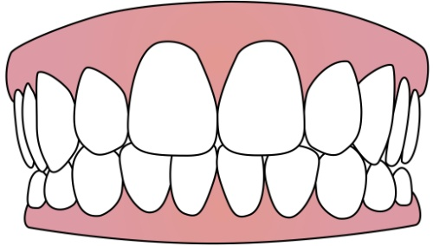

|  |  |  |  |  |  |  |  |  |  |  |  |  |  |  |  |  |  |  |  |
| --- | --- | --- | --- | --- | --- | --- | --- | --- | --- | --- | --- | --- | --- | --- | --- | --- | --- | --- | --- |
| **А** | **О** | **У** | **Е** | **Ы** | **Ч** | **М** | **Н** | **К** | **Г** | **Х** | **И** | **Ф** | **Б** | **П** | **Д** | **Т** | **С** | **З** | **Ц** |
| **1** | **2** | **3** | **4** | **5** | **6** | **7** | **8** | **9** | **10** | **11** | **12** | **13** | **14** | **15** | **16** | **17** | **18** | **19** | **20** |

|  |  |  |  |
| --- | --- | --- | --- |
| **8** | **2** | **10** | **4** |
|  |  |  |  |

 

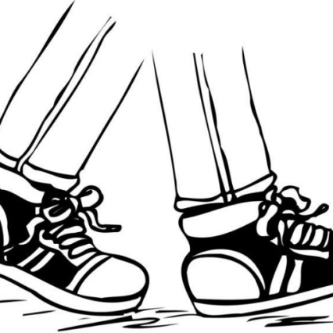

|  |  |  |  |  |  |  |  |  |  |  |  |  |  |  |  |  |  |  |  |
| --- | --- | --- | --- | --- | --- | --- | --- | --- | --- | --- | --- | --- | --- | --- | --- | --- | --- | --- | --- |
| **А** | **О** | **У** | **Е** | **Ы** | **Ч** | **М** | **Н** | **К** | **Г** | **Х** | **И** | **Ф** | **Б** | **П** | **Д** | **Т** | **С** | **З** | **Ц** |
| **1** | **2** | **3** | **4** | **5** | **6** | **7** | **8** | **9** | **10** | **11** | **12** | **13** | **14** | **15** | **16** | **17** | **18** | **19** | **20** |

|  |  |  |  |
| --- | --- | --- | --- |
| **10** | **3** | **14** | **5** |
|  |  |  |  |

 



|  |  |  |  |  |  |  |  |  |  |  |  |  |  |  |  |  |  |  |  |
| --- | --- | --- | --- | --- | --- | --- | --- | --- | --- | --- | --- | --- | --- | --- | --- | --- | --- | --- | --- |
| **А** | **О** | **У** | **Е** | **Ы** | **Ч** | **М** | **Н** | **К** | **Г** | **Х** | **И** | **Ф** | **Б** | **П** | **Д** | **Т** | **С** | **З** | **Ц** |
| **1** | **2** | **3** | **4** | **5** | **6** | **7** | **8** | **9** | **10** | **11** | **12** | **13** | **14** | **15** | **16** | **17** | **18** | **19** | **20** |

|  |  |  |  |
| --- | --- | --- | --- |
| **9** | **2** | **19** | **1** |
|  |  |  |  |

 

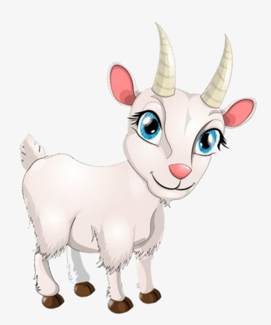

|  |  |  |  |  |  |  |  |  |  |  |  |  |  |  |  |  |  |  |  |
| --- | --- | --- | --- | --- | --- | --- | --- | --- | --- | --- | --- | --- | --- | --- | --- | --- | --- | --- | --- |
| **А** | **О** | **У** | **Е** | **Ы** | **Ч** | **М** | **Н** | **К** | **Г** | **Х** | **И** | **Ф** | **Б** | **П** | **Д** | **Т** | **С** | **З** | **Ц** |
| **1** | **2** | **3** | **4** | **5** | **6** | **7** | **8** | **9** | **10** | **11** | **12** | **13** | **14** | **15** | **16** | **17** | **18** | **19** | **20** |

|  |  |  |  |
| --- | --- | --- | --- |
| **8** | **2** | **17** | **5** |
|  |  |  |  |

 



|  |  |  |  |  |  |  |  |  |  |  |  |  |  |  |  |  |  |  |  |
| --- | --- | --- | --- | --- | --- | --- | --- | --- | --- | --- | --- | --- | --- | --- | --- | --- | --- | --- | --- |
| **А** | **О** | **У** | **Е** | **Ы** | **Ч** | **М** | **Н** | **К** | **Г** | **Х** | **И** | **Ф** | **Б** | **П** | **Д** | **Т** | **С** | **З** | **Ц** |
| **1** | **2** | **3** | **4** | **5** | **6** | **7** | **8** | **9** | **10** | **11** | **12** | **13** | **14** | **15** | **16** | **17** | **18** | **19** | **20** |

|  |  |  |  |
| --- | --- | --- | --- |
| **7** | **3** | **11** | **1** |
|  |  |  |  |

 

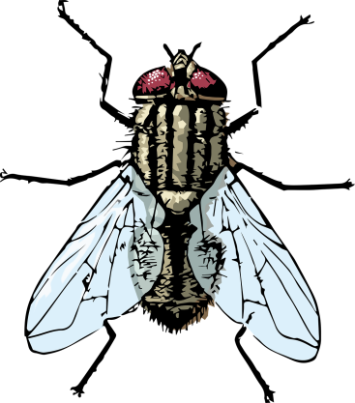

|  |  |  |  |  |  |  |  |  |  |  |  |  |  |  |  |  |  |  |  |
| --- | --- | --- | --- | --- | --- | --- | --- | --- | --- | --- | --- | --- | --- | --- | --- | --- | --- | --- | --- |
| **А** | **О** | **У** | **Е** | **Ы** | **Ч** | **М** | **Н** | **К** | **Г** | **Х** | **В** | **Ф** | **Б** | **П** | **Д** | **Т** | **С** | **З** | **Ц** |
| **1** | **2** | **3** | **4** | **5** | **6** | **7** | **8** | **9** | **10** | **11** | **12** | **13** | **14** | **15** | **16** | **17** | **18** | **19** | **20** |

|  |  |  |  |
| --- | --- | --- | --- |
| **18** | **2** | **12** | **1** |
|  |  |  |  |

 



|  |  |  |  |  |  |  |  |  |  |  |  |  |  |  |  |  |  |  |  |
| --- | --- | --- | --- | --- | --- | --- | --- | --- | --- | --- | --- | --- | --- | --- | --- | --- | --- | --- | --- |
| **А** | **О** | **У** | **Е** | **Ы** | **Ч** | **М** | **Н** | **К** | **Г** | **Х** | **И** | **Ф** | **Б** | **П** | **Д** | **Т** | **С** | **З** | **Ц** |
| **1** | **2** | **3** | **4** | **5** | **6** | **7** | **8** | **9** | **10** | **11** | **12** | **13** | **14** | **15** | **16** | **17** | **18** | **19** | **20** |

|  |  |  |  |
| --- | --- | --- | --- |
| **18** | **12** | **17** | **2** |
|  |  |  |  |

 

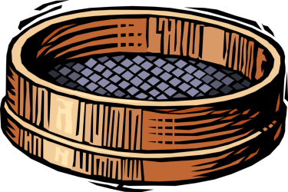

|  |  |  |  |  |  |  |  |  |  |  |  |  |  |  |  |  |  |  |  |
| --- | --- | --- | --- | --- | --- | --- | --- | --- | --- | --- | --- | --- | --- | --- | --- | --- | --- | --- | --- |
| **А** | **О** | **У** | **Е** | **Ы** | **Ч** | **М** | **Н** | **К** | **Г** | **Х** | **И** | **Ф** | **Б** | **П** | **Д** | **Т** | **С** | **З** | **Ц** |
| **1** | **2** | **3** | **4** | **5** | **6** | **7** | **8** | **9** | **10** | **11** | **12** | **13** | **14** | **15** | **16** | **17** | **18** | **19** | **20** |

|  |  |  |  |
| --- | --- | --- | --- |
| **7** | **6** | **8** | **1** |
|  |  |  |  |

 

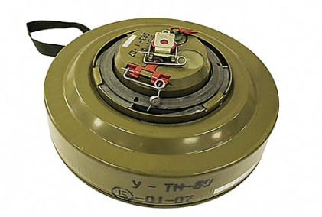

|  |  |  |  |  |  |  |  |  |  |  |  |  |  |  |  |  |  |  |  |
| --- | --- | --- | --- | --- | --- | --- | --- | --- | --- | --- | --- | --- | --- | --- | --- | --- | --- | --- | --- |
| **А** | **О** | **У** | **Е** | **Ы** | **Ч** | **М** | **Н** | **К** | **Г** | **Х** | **И** | **Ф** | **Б** | **П** | **Д** | **Т** | **С** | **З** | **Ц** |
| **1** | **2** | **3** | **4** | **5** | **6** | **7** | **8** | **9** | **10** | **11** | **12** | **13** | **14** | **15** | **16** | **17** | **18** | **19** | **20** |

|  |  |  |  |  |
| --- | --- | --- | --- | --- |
| **14** | **1** | **17** | **2** | **8** |
|  |  |  |  |  |

 



|  |  |  |  |  |  |  |  |  |  |  |  |  |  |  |  |  |  |  |  |
| --- | --- | --- | --- | --- | --- | --- | --- | --- | --- | --- | --- | --- | --- | --- | --- | --- | --- | --- | --- |
| **А** | **О** | **У** | **Е** | **Ы** | **Ч** | **М** | **Н** | **К** | **Г** | **Х** | **И** | **Ф** | **Б** | **П** | **Д** | **Т** | **С** | **З** | **Ц** |
| **1** | **2** | **3** | **4** | **5** | **6** | **7** | **8** | **9** | **10** | **11** | **12** | **13** | **14** | **15** | **16** | **17** | **18** | **19** | **20** |

|  |  |  |  |  |
| --- | --- | --- | --- | --- |
| **9** | **1** | **14** | **1** | **8** |
|  |  |  |  |  |

 

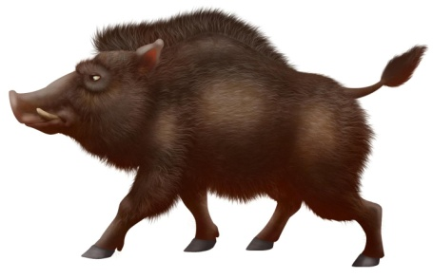

|  |  |  |  |  |  |  |  |  |  |  |  |  |  |  |  |  |  |  |  |
| --- | --- | --- | --- | --- | --- | --- | --- | --- | --- | --- | --- | --- | --- | --- | --- | --- | --- | --- | --- |
| **А** | **О** | **У** | **Е** | **Ы** | **Ч** | **М** | **Н** | **К** | **Г** | **Х** | **И** | **Ф** | **Б** | **П** | **Д** | **Т** | **С** | **З** | **Ц** |
| **1** | **2** | **3** | **4** | **5** | **6** | **7** | **8** | **9** | **10** | **11** | **12** | **13** | **14** | **15** | **16** | **17** | **18** | **19** | **20** |

|  |  |  |  |  |
| --- | --- | --- | --- | --- |
| **18** | **1** | **8** | **9** | **12** |
|  |  |  |  |  |

 

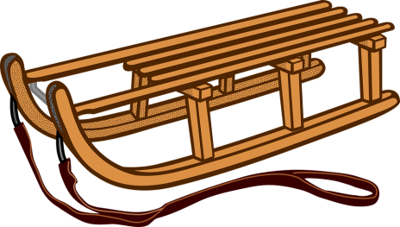

|  |  |  |  |  |  |  |  |  |  |  |  |  |  |  |  |  |  |  |  |
| --- | --- | --- | --- | --- | --- | --- | --- | --- | --- | --- | --- | --- | --- | --- | --- | --- | --- | --- | --- |
| **А** | **О** | **У** | **Е** | **Ы** | **Ч** | **М** | **Н** | **К** | **Г** | **Х** | **И** | **Ф** | **Б** | **П** | **Д** | **Т** | **С** | **З** | **Ц** |
| **1** | **2** | **3** | **4** | **5** | **6** | **7** | **8** | **9** | **10** | **11** | **12** | **13** | **14** | **15** | **16** | **17** | **18** | **19** | **20** |

|  |  |  |  |  |
| --- | --- | --- | --- | --- |
| **14** | **3** | **16** | **9** | **1** |
|  |  |  |  |  |

 



|  |  |  |  |  |  |  |  |  |  |  |  |  |  |  |  |  |  |  |  |
| --- | --- | --- | --- | --- | --- | --- | --- | --- | --- | --- | --- | --- | --- | --- | --- | --- | --- | --- | --- |
| **А** | **О** | **У** | **Е** | **Ы** | **Ч** | **М** | **Н** | **К** | **Г** | **Х** | **И** | **Ф** | **Б** | **П** | **Д** | **Т** | **С** | **З** | **Ц** |
| **1** | **2** | **3** | **4** | **5** | **6** | **7** | **8** | **9** | **10** | **11** | **12** | **13** | **14** | **15** | **16** | **17** | **18** | **19** | **20** |

|  |  |  |  |  |
| --- | --- | --- | --- | --- |
| **9** | **3** | **14** | **2** | **9** |
|  |  |  |  |  |

 



|  |  |  |  |  |  |  |  |  |  |  |  |  |  |  |  |  |  |  |  |
| --- | --- | --- | --- | --- | --- | --- | --- | --- | --- | --- | --- | --- | --- | --- | --- | --- | --- | --- | --- |
| **А** | **О** | **У** | **Е** | **Ы** | **Ч** | **М** | **Н** | **К** | **Г** | **Х** | **И** | **Ф** | **Б** | **П** | **Д** | **Т** | **С** | **З** | **Ц** |
| **1** | **2** | **3** | **4** | **5** | **6** | **7** | **8** | **9** | **10** | **11** | **12** | **13** | **14** | **15** | **16** | **17** | **18** | **19** | **20** |

|  |  |  |  |  |
| --- | --- | --- | --- | --- |
| **17** | **1** | **15** | **9** | **12** |
|  |  |  |  |  |

 

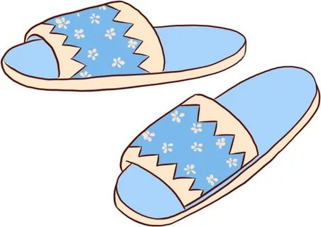

|  |  |  |  |  |  |  |  |  |  |  |  |  |  |  |  |  |  |  |  |
| --- | --- | --- | --- | --- | --- | --- | --- | --- | --- | --- | --- | --- | --- | --- | --- | --- | --- | --- | --- |
| **А** | **О** | **У** | **И** | **Ы** | **Ч** | **М** | **Н** | **К** | **Г** | **Х** | **В** | **Ф** | **Б** | **П** | **Д** | **Т** | **С** | **З** | **Ц** |
| **1** | **2** | **3** | **4** | **5** | **6** | **7** | **8** | **9** | **10** | **11** | **12** | **13** | **14** | **15** | **16** | **17** | **18** | **19** | **20** |

|  |  |  |  |  |
| --- | --- | --- | --- | --- |
| **12** | **1** | **10** | **2** | **8** |
|  |  |  |  |  |

 



|  |  |  |  |  |  |  |  |  |  |  |  |  |  |  |  |  |  |  |  |
| --- | --- | --- | --- | --- | --- | --- | --- | --- | --- | --- | --- | --- | --- | --- | --- | --- | --- | --- | --- |
| **А** | **О** | **У** | **Е** | **Ы** | **Й** | **М** | **Н** | **К** | **Г** | **Х** | **И** | **Ф** | **Б** | **П** | **Д** | **Т** | **С** | **З** | **Ц** |
| **1** | **2** | **3** | **4** | **5** | **6** | **7** | **8** | **9** | **10** | **11** | **12** | **13** | **14** | **15** | **16** | **17** | **18** | **19** | **20** |

|  |  |  |  |  |
| --- | --- | --- | --- | --- |
| **7** | **6** | **18** | **9** | **1** |
|  |  |  |  |  |

 

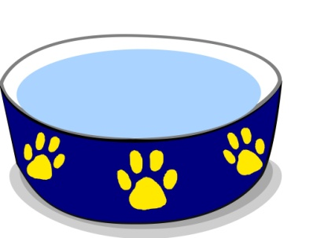

|  |  |  |  |  |  |  |  |  |  |  |  |  |  |  |  |  |  |  |  |
| --- | --- | --- | --- | --- | --- | --- | --- | --- | --- | --- | --- | --- | --- | --- | --- | --- | --- | --- | --- |
| **А** | **О** | **У** | **Е** | **Ы** | **Й** | **М** | **Н** | **К** | **Г** | **Х** | **В** | **Ф** | **Б** | **П** | **Д** | **Т** | **С** | **З** | **Ц** |
| **1** | **2** | **3** | **4** | **5** | **6** | **7** | **8** | **9** | **10** | **11** | **12** | **13** | **14** | **15** | **16** | **17** | **18** | **19** | **20** |

|  |  |  |  |  |
| --- | --- | --- | --- | --- |
| **17** | **5** | **9** | **12** | **1** |
|  |  |  |  |  |

 



|  |  |  |  |  |  |  |  |  |  |  |  |  |  |  |  |  |  |  |  |
| --- | --- | --- | --- | --- | --- | --- | --- | --- | --- | --- | --- | --- | --- | --- | --- | --- | --- | --- | --- |
| **А** | **О** | **У** | **Е** | **Ы** | **Й** | **М** | **Н** | **К** | **Г** | **Х** | **И** | **Ф** | **Б** | **П** | **Д** | **Т** | **С** | **З** | **Ц** |
| **1** | **2** | **3** | **4** | **5** | **6** | **7** | **8** | **9** | **10** | **11** | **12** | **13** | **14** | **15** | **16** | **17** | **18** | **19** | **20** |

|  |  |  |  |  |
| --- | --- | --- | --- | --- |
| **10** | **1** | **7** | **1** | **9** |
|  |  |  |  |  |

 

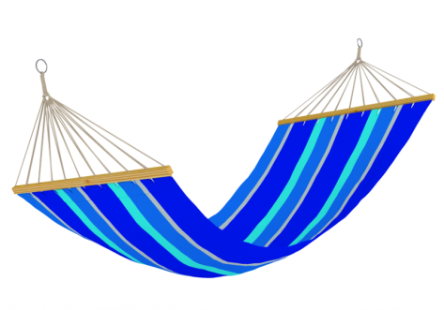

|  |  |  |  |  |  |  |  |  |  |  |  |  |  |  |  |  |  |  |  |
| --- | --- | --- | --- | --- | --- | --- | --- | --- | --- | --- | --- | --- | --- | --- | --- | --- | --- | --- | --- |
| **А** | **О** | **У** | **Е** | **Ы** | **Й** | **М** | **Н** | **К** | **Г** | **Х** | **И** | **Ф** | **Б** | **П** | **Д** | **Т** | **С** | **З** | **Ц** |
| **1** | **2** | **3** | **4** | **5** | **6** | **7** | **8** | **9** | **10** | **11** | **12** | **13** | **14** | **15** | **16** | **17** | **18** | **19** | **20** |

|  |  |  |  |  |  |
| --- | --- | --- | --- | --- | --- |
| **14** | **3** | **7** | **1** | **10** | **1** |
|  |  |  |  |  |  |

 



|  |  |  |  |  |  |  |  |  |  |  |  |  |  |  |  |  |  |  |  |
| --- | --- | --- | --- | --- | --- | --- | --- | --- | --- | --- | --- | --- | --- | --- | --- | --- | --- | --- | --- |
| **А** | **О** | **У** | **Е** | **Ы** | **Й** | **М** | **Н** | **К** | **Г** | **Х** | **И** | **Ф** | **Б** | **П** | **Д** | **Т** | **С** | **З** | **Ц** |
| **1** | **2** | **3** | **4** | **5** | **6** | **7** | **8** | **9** | **10** | **11** | **12** | **13** | **14** | **15** | **16** | **17** | **18** | **19** | **20** |

|  |  |  |  |  |  |
| --- | --- | --- | --- | --- | --- |
| **19** | **1** | **8** | **2** | **19** | **1** |
|  |  |  |  |  |  |

 

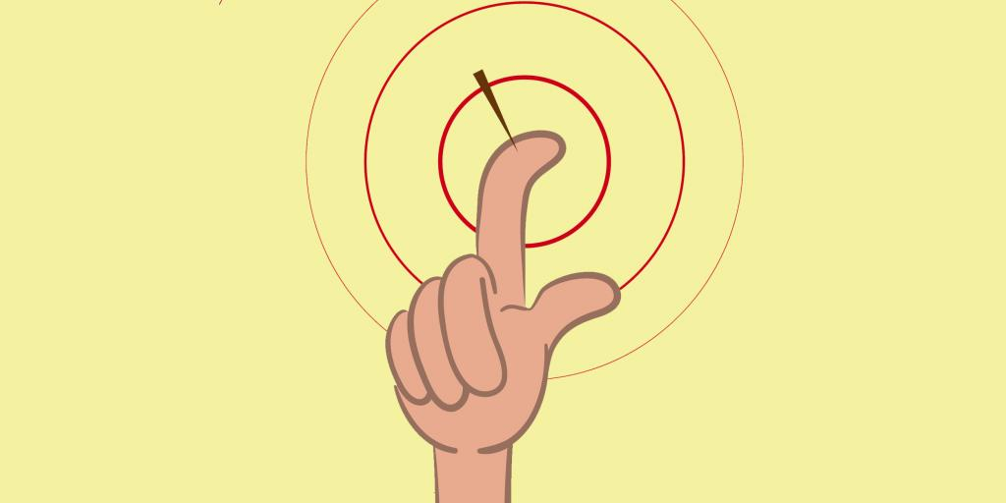

|  |  |  |  |  |  |  |  |  |  |  |  |  |  |  |  |  |  |  |  |
| --- | --- | --- | --- | --- | --- | --- | --- | --- | --- | --- | --- | --- | --- | --- | --- | --- | --- | --- | --- |
| **А** | **О** | **У** | **Е** | **Ы** | **Й** | **М** | **Н** | **К** | **Г** | **Х** | **И** | **Ф** | **Б** | **П** | **Д** | **Т** | **С** | **З** | **Ц** |
| **1** | **2** | **3** | **4** | **5** | **6** | **7** | **8** | **9** | **10** | **11** | **12** | **13** | **14** | **15** | **16** | **17** | **18** | **19** | **20** |

|  |  |  |  |  |  |
| --- | --- | --- | --- | --- | --- |
| **18** | **4** | **8** | **4** | **20** | **1** |
|  |  |  |  |  |  |

 

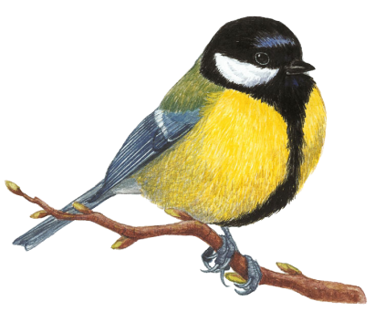

|  |  |  |  |  |  |  |  |  |  |  |  |  |  |  |  |  |  |  |  |
| --- | --- | --- | --- | --- | --- | --- | --- | --- | --- | --- | --- | --- | --- | --- | --- | --- | --- | --- | --- |
| **А** | **О** | **У** | **И** | **Ы** | **Й** | **М** | **Н** | **К** | **Г** | **Х** | **В** | **Ф** | **Б** | **П** | **Д** | **Т** | **С** | **З** | **Ц** |
| **1** | **2** | **3** | **4** | **5** | **6** | **7** | **8** | **9** | **10** | **11** | **12** | **13** | **14** | **15** | **16** | **17** | **18** | **19** | **20** |

|  |  |  |  |  |  |
| --- | --- | --- | --- | --- | --- |
| **12** | **1** | **10** | **2** | **8** | **5** |
|  |  |  |  |  |  |

 



|  |  |  |  |  |  |  |  |  |  |  |  |  |  |  |  |  |  |  |  |
| --- | --- | --- | --- | --- | --- | --- | --- | --- | --- | --- | --- | --- | --- | --- | --- | --- | --- | --- | --- |
| **А** | **О** | **У** | **Е** | **Ы** | **Й** | **М** | **Н** | **К** | **Г** | **Х** | **И** | **Ф** | **Б** | **П** | **Д** | **Т** | **С** | **З** | **Ц** |
| **1** | **2** | **3** | **4** | **5** | **6** | **7** | **8** | **9** | **10** | **11** | **12** | **13** | **14** | **15** | **16** | **17** | **18** | **19** | **20** |

|  |  |  |  |  |  |
| --- | --- | --- | --- | --- | --- |
| **13** | **12** | **8** | **12** | **9** | **12** |
|  |  |  |  |  |  |

 

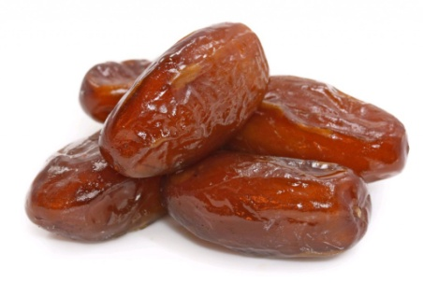

|  |  |  |  |  |  |  |  |  |  |  |  |  |  |  |  |  |  |  |  |
| --- | --- | --- | --- | --- | --- | --- | --- | --- | --- | --- | --- | --- | --- | --- | --- | --- | --- | --- | --- |
| **А** | **О** | **У** | **Е** | **Ы** | **Й** | **М** | **Н** | **К** | **Г** | **Х** | **И** | **Ф** | **Б** | **П** | **Д** | **Т** | **С** | **Л** | **Ц** |
| **1** | **2** | **3** | **4** | **5** | **6** | **7** | **8** | **9** | **10** | **11** | **12** | **13** | **14** | **15** | **16** | **17** | **18** | **19** | **20** |

|  |  |  |  |  |  |
| --- | --- | --- | --- | --- | --- |
| **9** | **1** | **19** | **12** | **8** | **1** |
|  |  |  |  |  |  |

 

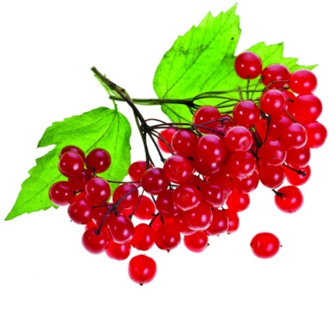

|  |  |  |  |  |  |  |  |  |  |  |  |  |  |  |  |  |  |  |  |
| --- | --- | --- | --- | --- | --- | --- | --- | --- | --- | --- | --- | --- | --- | --- | --- | --- | --- | --- | --- |
| **А** | **О** | **У** | **Е** | **Ы** | **Й** | **М** | **Н** | **К** | **Г** | **Х** | **И** | **Ф** | **Б** | **П** | **Д** | **Т** | **С** | **Л** | **Ц** |
| **1** | **2** | **3** | **4** | **5** | **6** | **7** | **8** | **9** | **10** | **11** | **12** | **13** | **14** | **15** | **16** | **17** | **18** | **19** | **20** |

|  |  |  |  |  |  |
| --- | --- | --- | --- | --- | --- |
| **8** | **1** | **19** | **12** | **8** | **1** |
|  |  |  |  |  |  |

 

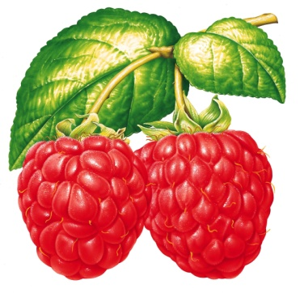

|  |  |  |  |  |  |  |  |  |  |  |  |  |  |  |  |  |  |  |  |
| --- | --- | --- | --- | --- | --- | --- | --- | --- | --- | --- | --- | --- | --- | --- | --- | --- | --- | --- | --- |
| **А** | **О** | **У** | **Е** | **Ы** | **Й** | **М** | **Н** | **К** | **Г** | **Х** | **И** | **Ф** | **Б** | **П** | **Д** | **Т** | **С** | **З** | **Ц** |
| **1** | **2** | **3** | **4** | **5** | **6** | **7** | **8** | **9** | **10** | **11** | **12** | **13** | **14** | **15** | **16** | **17** | **18** | **19** | **20** |

|  |  |  |  |  |  |
| --- | --- | --- | --- | --- | --- |
| **16** | **2** | **7** | **12** | **8** | **2** |
|  |  |  |  |  |  |

 

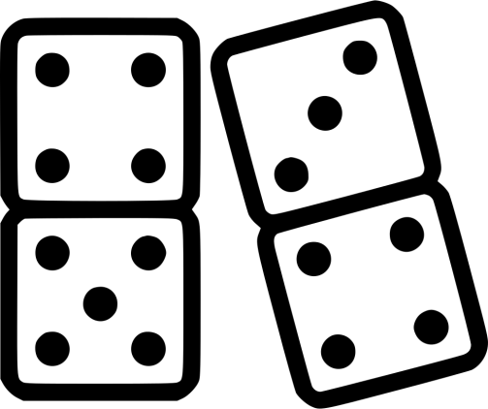

|  |  |  |  |  |  |  |  |  |  |  |  |  |  |  |  |  |  |  |  |
| --- | --- | --- | --- | --- | --- | --- | --- | --- | --- | --- | --- | --- | --- | --- | --- | --- | --- | --- | --- |
| **А** | **О** | **У** | **Е** | **Ы** | **Й** | **М** | **Н** | **К** | **Г** | **Х** | **И** | **Ф** | **Б** | **П** | **Д** | **Т** | **С** | **З** | **Ц** |
| **1** | **2** | **3** | **4** | **5** | **6** | **7** | **8** | **9** | **10** | **11** | **12** | **13** | **14** | **15** | **16** | **17** | **18** | **19** | **20** |

|  |  |  |  |  |  |
| --- | --- | --- | --- | --- | --- |
| **16** | **3** | **14** | **12** | **8** | **1** |
|  |  |  |  |  |  |

 

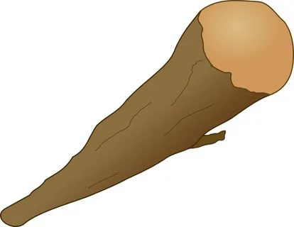

|  |  |  |  |  |  |  |  |  |  |  |  |  |  |  |  |  |  |  |  |
| --- | --- | --- | --- | --- | --- | --- | --- | --- | --- | --- | --- | --- | --- | --- | --- | --- | --- | --- | --- |
| **А** | **О** | **У** | **Е** | **Ы** | **Й** | **М** | **Н** | **К** | **Г** | **Х** | **И** | **Ф** | **Б** | **П** | **Д** | **Т** | **С** | **З** | **Ц** |
| **1** | **2** | **3** | **4** | **5** | **6** | **7** | **8** | **9** | **10** | **11** | **12** | **13** | **14** | **15** | **16** | **17** | **18** | **19** | **20** |

|  |  |  |  |  |  |
| --- | --- | --- | --- | --- | --- |
| **18** | **1** | **15** | **2** | **10** | **12** |
|  |  |  |  |  |  |

 

